**Industrial Internship Report on**

**”HOME AUTOMATION SYSTEM”**

**Prepared by**

**[Paresh Kalsotra]**

|  |
| --- |
| *Executive Summary* |
| The report is based on the 6 weeks Industrial Internship journey provided by Upskill Campus and The IoT Academy in collaboration with Industrial Partner UniConverge Technologies Pvt Ltd (UCT). Upskill Campus along with The IoT Academy and in association with Uniconverge technologies has facilitated the smooth execution of the complete internship process. Each and every member was great in dealing with student queries and the replies were very helpful.  This internship was project based and we had to finish the project including the report in 6 weeks time. The first three weeks were little challenging as I dealt with new things. The next three weeks were very effective and I learnt many things throughout my journey.  This internship provided me with necessary exposure regarding various problems based on industrial grade and gave me a very good opportunity to implement solution for that. It was an overall great experience to have this internship. |

**TABLE OF CONTENTS**

1 Preface 3

2 Acknowledgement 4

3 Introduction……………………………………………………………………………………………………………………………………….5

3.1 About UniConverge Technologies Pvt Ltd 5

3.2 About upskill Campus 9

3.3 About The IoT Academy 10

3.4 Objective 10

3.5 Reference 11

4 Problem Statement 12

5 Existing and Proposed solution 13

6 Proposed Design/ Model 15

6.1 Low Level Diagram 16

6.2 High Level Diagram 16

6.3 BLYNK Interfaces 18

7 Performance Test 21

7.1 Test Plan 21

7.2 Test Cases 22

7.3 Test Procedure 23

7.4 Performance Outcome 25

8 My Learnings 27

9 Future Scope 28

# Preface

In modern day world, everything is being automated from home to colleges and from offices to industries. Devices and machines are being automated to reduce the human efforts and it additionally saves energy and time. With the event of latest technologies, the ability to connect with one another through network is phenomenal. Internet of Things may be a network of interconnected devices, designed to gather and exchange information which may then flip it into data, eventually into knowledge. With internships like the one provided by Upskill Campus, students get more skilled and they get a chance to brainstorm themselves to develop useful devices and objects. For a beginner it is a perfect opportunity to start the development of his or her skill set and in turn develop his or her career.

There were many projects given to us and out of which we had to choose one project. The privilege of choosing more than one project was also given to us. I chose “HOME AUTOMATION SYSTEM” as my internship project as I really wanted to get deep in this IoT field particularly. I personally wanted to learn more out of the automation systems like how they work, what are the innovation opportunity etc. to which USC/UCT has provided the students one of the best platform to learn and explore. Additionally they have given the freedom to each and every student to make and choose topic of their own.

This 6 weeks journey was nicely planned. At the end of each week, reports of weekly work were asked to submit and the queries were attended very nicely.

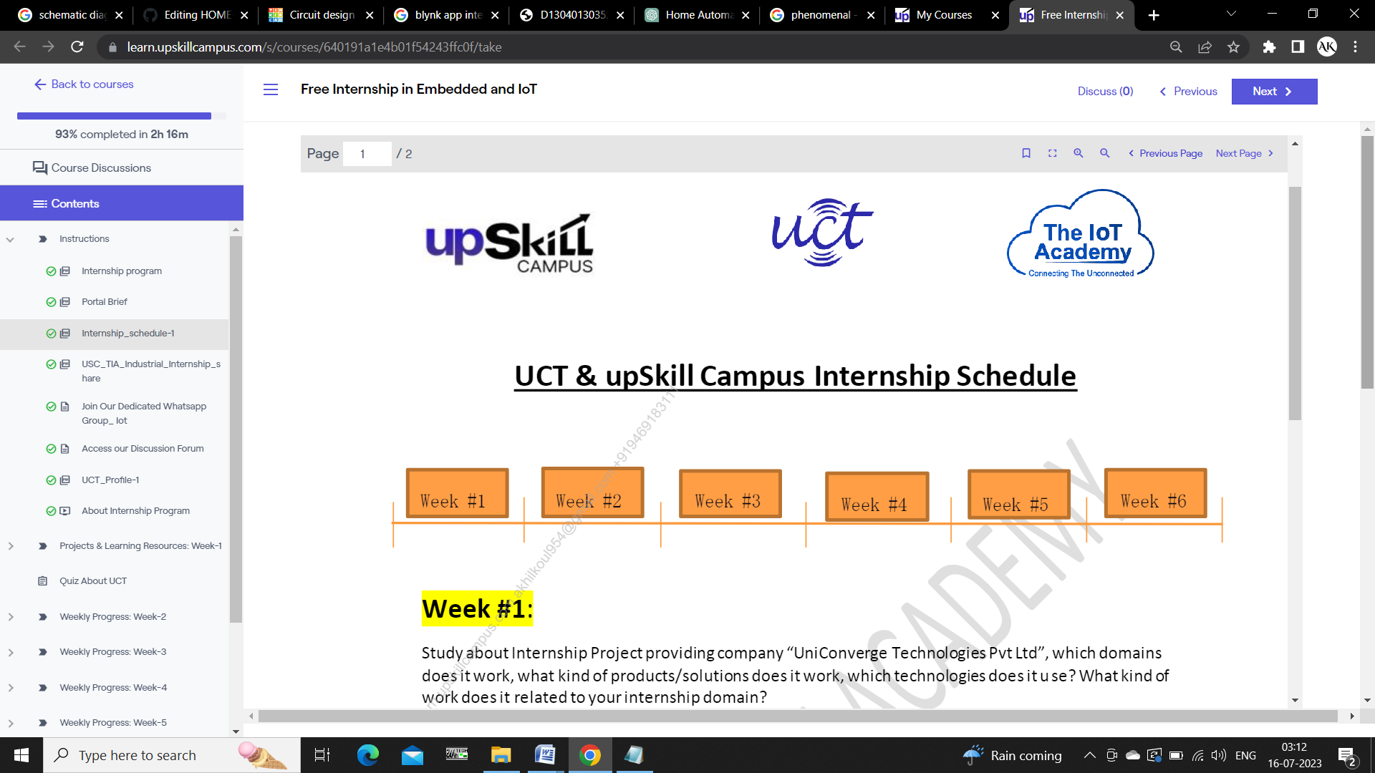

* Week1: This week was full of exploring more about UCT and choosing the problem statement
* Week2: This week focused on making a plan
* Week3:In this week the design making and implementation was started
* Week4: In this week we extended our project design and made necessary changes
* Week5: This week was to fix errors and test the model developed
* Week6: The final week markedthe project completion week

# 2 ACKNOWLEDGEMNT

I would like to express my heartfelt gratitude to all the individuals who have contributed to the creation of my project on “Home Automation”. Without their support, expertise, and encouragement, this project would not have been possible. A special thanks to Respected Sir, **Kaushlendra Sisodia,** Director at **UniConverge Technologies Pvt. Ltd.** for providing necessary guidance. The interactive sessions conducted were very useful to us.

I also extend my deepest appreciation to my family and friends for their unwavering support and understanding throughout this journey. Their encouragement and belief in me provided the motivation to keep going, even during challenging times. I am profoundly thankful to the team at Upskill Campus, The IoT Academy and UniConverge Technologies Pvt Ltd (UCT) who have worked tirelessly during this 6 weeks.

Lastly, my heartfelt gratitude goes to all the individuals who participated in the testing and provided valuable feedback. Their insights and suggestions have immensely improved the quality and effectiveness of this project.

# Introduction

## About UniConverge Technologies Pvt Ltd

A company established in 2013 and working in Digital Transformation domain and providing Industrial solutions with prime focus on sustainability and RoI.

For developing its products and solutions it is leveraging variousCutting Edge Technologies e.g. Internet of Things (IoT), Cyber Security, Cloud computing (AWS, Azure), Machine Learning, Communication Technologies (4G/5G/LoRaWAN), Java Full Stack, Python, Front endetc.

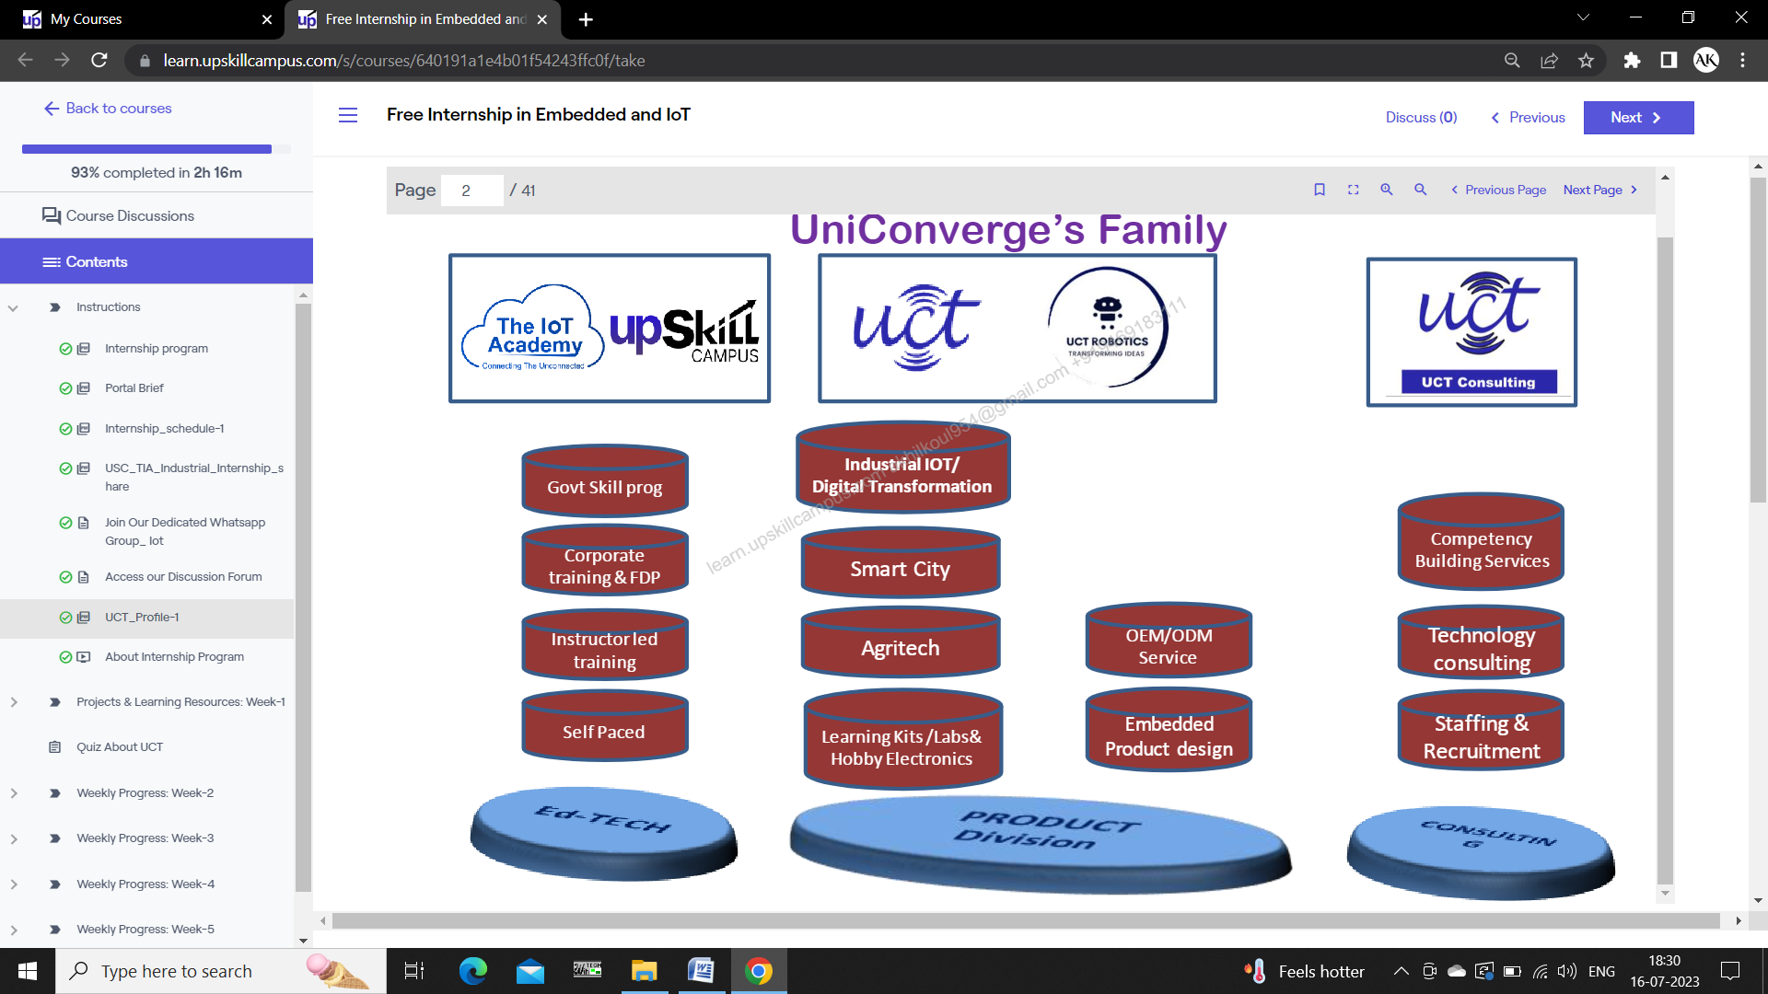

Figure

1. UCT IoT Platform 

**UCT Insight** is an IOT platform designed for quick deployment of IOT applications on the same time providing valuable “insight” for your process/business. It has been built in Java for backend and ReactJS for Front end. It has support for MySQL and various NoSql Databases.

* It enables device connectivity via industry standard IoT protocols - MQTT, CoAP, HTTP, Modbus TCP, OPC UA
* It supports both cloud and on-premises deployments.

It has features to  
• Build Your own dashboard  
• Analytics and Reporting  
• Alert and Notification  
• Integration with third party application (Power BI, SAP, ERP)  
• Rule Engine

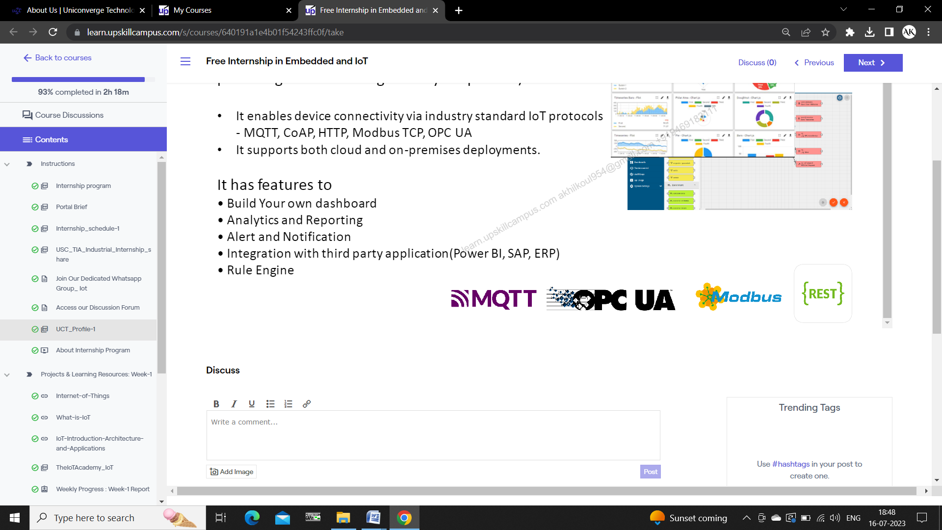



Figure

1. **Smart Factory Platform (****)**

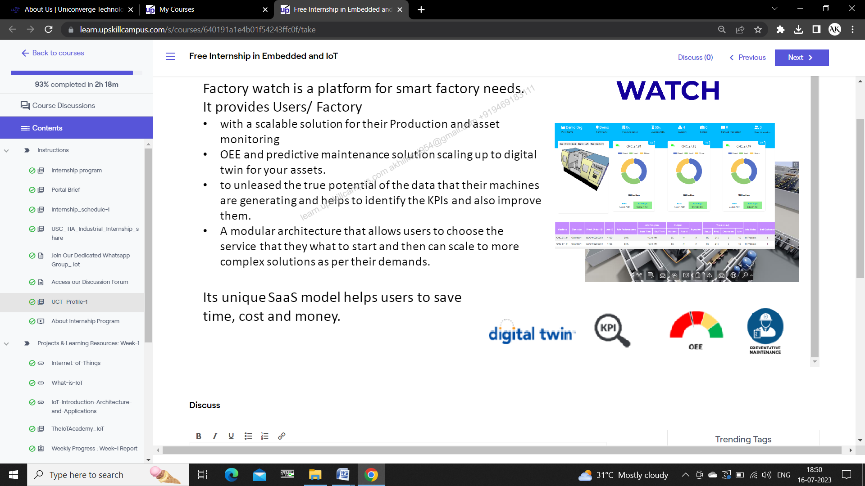Factory watch is a platform for smart factory needs.

It provides Users/ Factory

* with a scalable solution for their Production and asset monitoring
* OEE and predictive maintenance solution scaling up to digital twin for your assets.
* to unleased the true potential of the data that their machines are generating and helps to identify the KPIs and also improve them.
* A modular architecture that allows users to choose the service that they what to start and then can scale to more complex solutions as per their demands.

Its unique SaaS model helps users to save time, cost and money.

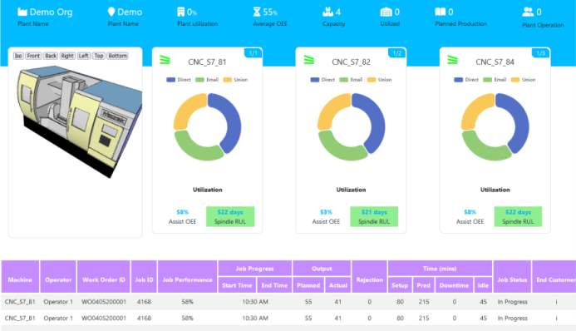 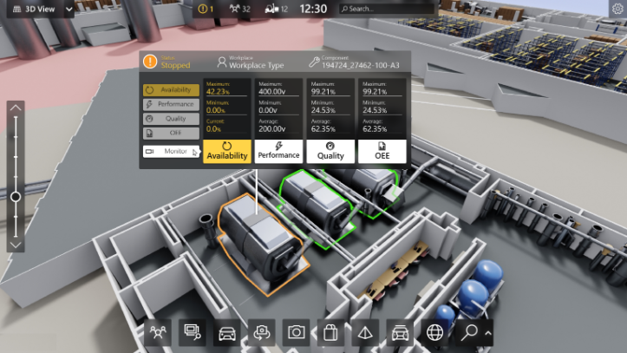

Figure

1. based Solution

**UCT**  is one of the early adopters of LoRAWAN teschnology and providing solution in Agritech, Smart cities, Industrial Monitoring, Smart Street Light, Smart Water/ Gas/ Electricity metering solutions etc.

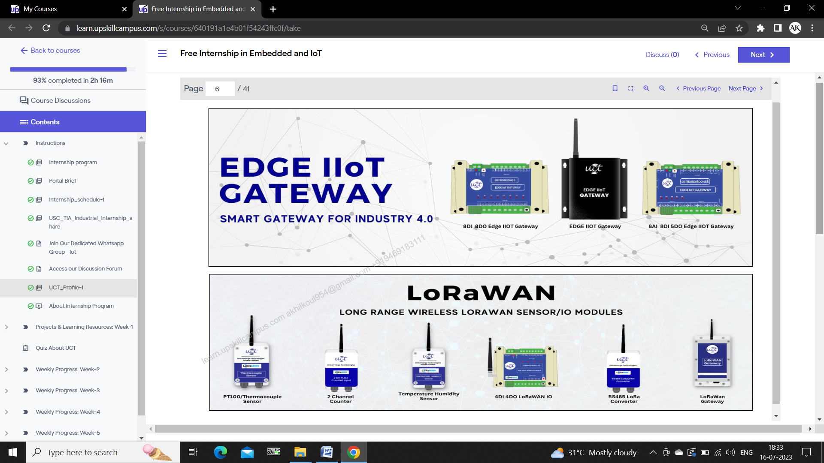

Figure

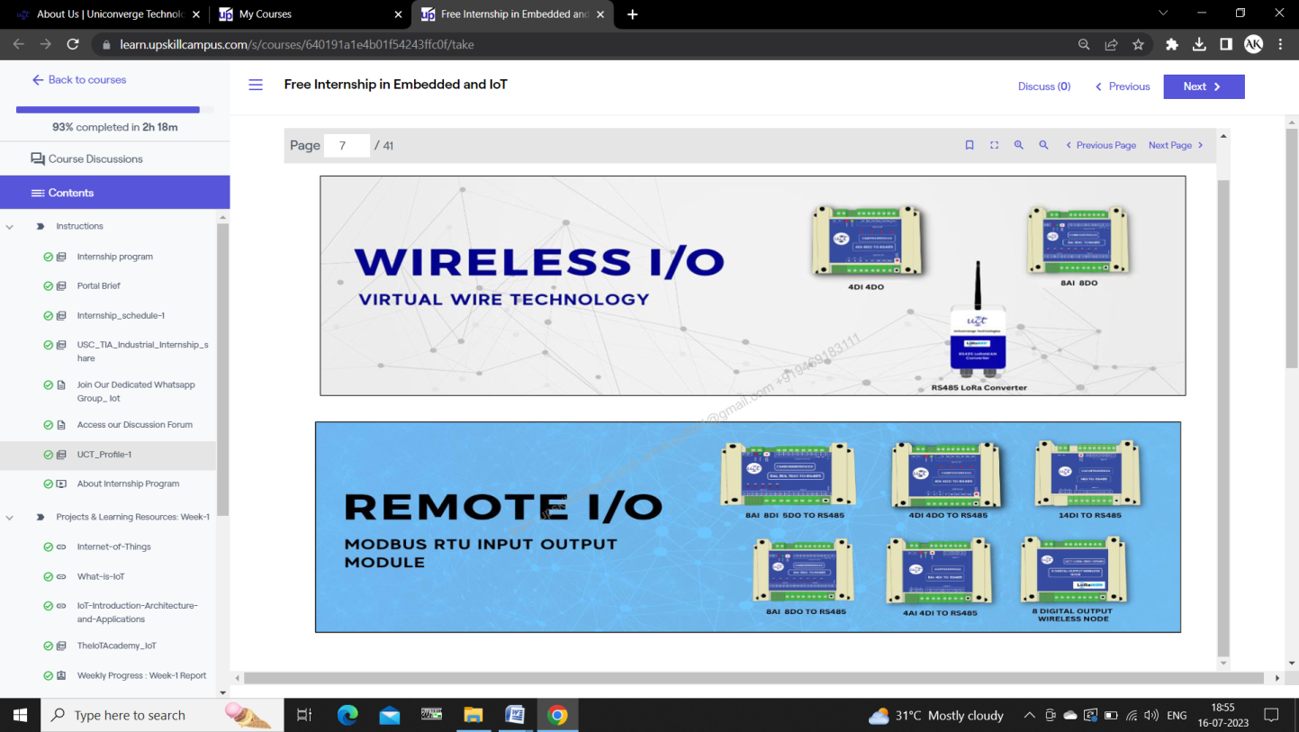

Figure

1. **Predictive Maintenance**

**UCT** is providing Industrial Machine health monitoring and Predictive maintenance solution leveraging Embedded system, Industrial IoT and Machine Learning Technologies by finding Remaining useful life time of various machines used in production process.



Figure

## About upskill Campus (USC)



Seeing need of upskilling in self paced manner along-with additional support services e.g. Internship, projects, interaction with Industry experts, Career growth Services

UpSkill Campus aiming to upskill 1 million learners in next 5 year

**Upskill Campus** along with The IoT Academy and in association with Uniconverge technologies has facilitated the smooth execution of the complete internship process.

USC is a career development platform that delivers **personalized executive coaching** in a more affordable, scalable and measurable way.



## About The IoT Academy

The IoT academy is EdTech Division of UCT that is running long executive certification programs in collaboration with EICT Academy, IITK, IITR and IITG in multiple domains. It is an NCR Based Firm founded and guided by a group of IT Professionals having excellent experience in various IT Sectors and who have been working in MNCs for past years. They are specialized in education and skill development programs which help students to brighten their career.

**3.4 Objectives of this Internship program**

The objective for this internship program was to

 ☛ get practical experience of working in the industry.

 ☛ to solve real world problems.

 ☛ to have improved job prospects.

 ☛to have Improved understanding of our field and its applications.

 ☛to have Personal growth like better communication and problem solving.

## Reference

[1] https://www.upskillcampus.com/

[2] https://www.linkedin.com/company/upskillcampus/

[3] <https://www.theiotacademy.co/>

[4] https://www.uniconvergetech.in/

# Problem Statement

As we know the present day home systems are not automated, that is they have to be controlled manually using physical switches. On individual level it is time consuming and leads to unnecessary power wastage. Hence, it becomes crucial to monitor these appliances closely. Additionally, there are several challenges such as maintenance, security, connectivity, and the need for physical presence. However, by effectively addressing these obstacles, we can create an environment where users can effortlessly control and manage their smart devices. This, in turn, will lead to greater adoption of home automation and a more fulfilling user experience.

So the problem proposed was to design and implement a “Home Automation System” using Microcontrollers so that there can be automation in home appliances also. The suggested microcontrollers were Node MCU and arduino and the automation had to be controlled using third party website or app.

The objectives needed to be achieved were as follows:

• Energy Efficient Systems

• Increased Convenience

• Remote Access

• Automated Control

• Better Security

# Existing and Proposed solution

The existing solutions included simple home systems having one microcontroller and Wi-Fi Module control. I tried to implement the home automation using occupancy detection of persons in range using PIR Motion Detection. This resulted in automation of the home lighting system, resulting in power saving, smart activation.

**DISADVANTAGES OF EXISTING SYSTEM:**

The existing system was operated manually but not being physically present to operate the home appliances. But the problem still existed when the user itself forgets to turn off the appliances. Also there are some system provides a way to operate appliances through third party app but people forget to turn off the appliances through third party apps also, which leads to the wastage of energy. That is why the automation part was necessary which is still missing.

**PROPOSED SOLUTION:**

One solution was to create a home automation system that can remotely control the home appliances and also provide automatic operation of lights using pir sensor. It uses esp32 module for wifi connectivity and blynk app provides the interface for remote control of appliances. The system is also able to detect the occupancy and then turn off appliances when occupancy was not detected. This solution was implemented by adding PIR Motion Detection Sensor which regulated appliances in use. In addition the user also had the access to control the appliances whenever needed.

This solution can be aided by the use a LDR circuitry. Whenever needed the decision can be made by taking in consideration the outputs of both PIR Motion Sensor and LDR circuit.

## Code submission (Github link):

## <https://github.com/Paresh-Kalsotra/IoT-Based-Home-Automation-System>

# Proposed Design/ Model

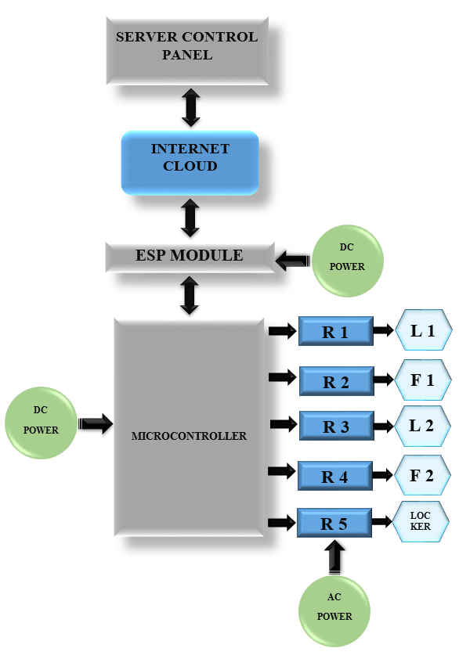

Figure

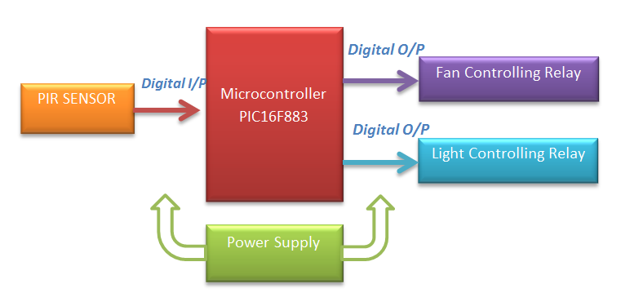

ESP32

Figure

* Fig.7 explains the flow of signals between the different components of the system and its connection with the third party server having automation in control
* Fig.8 explains the circuit flow of PIR Sensor with NODE MCU esp32

## Low Level Diagrams

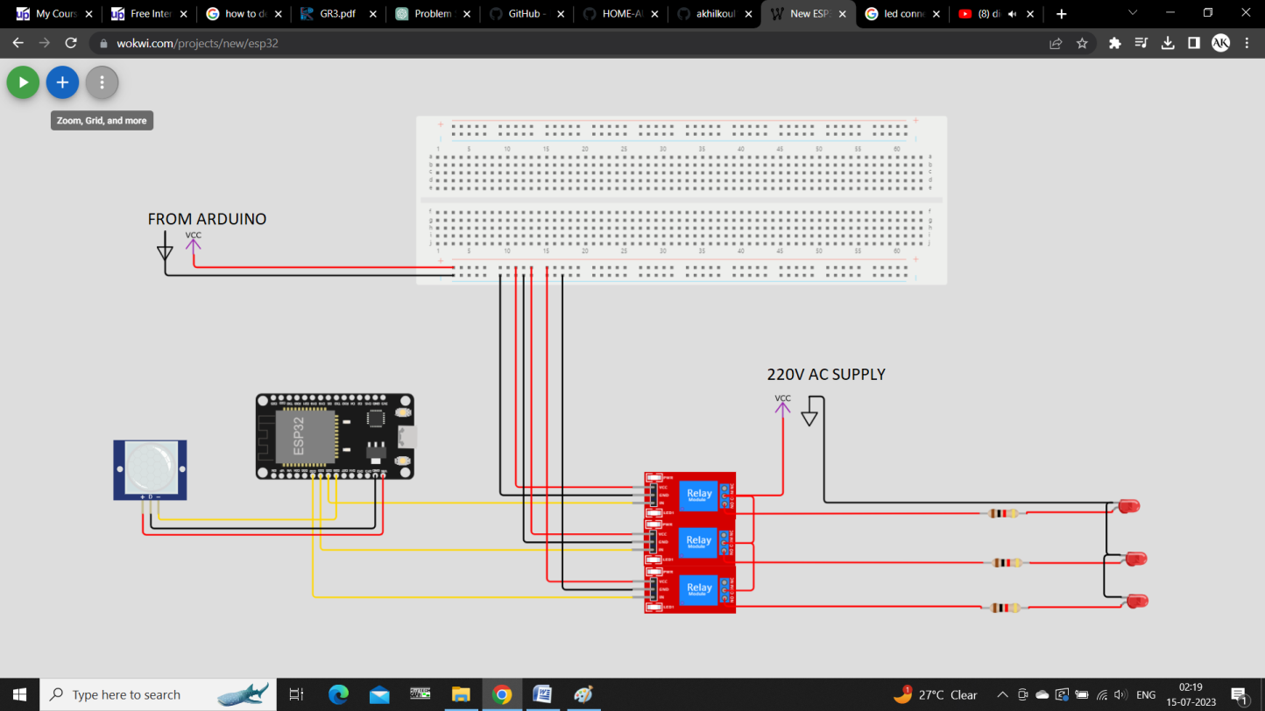

Figure

* Fig.9 explains circuit flow using ESP32 Microcontroller

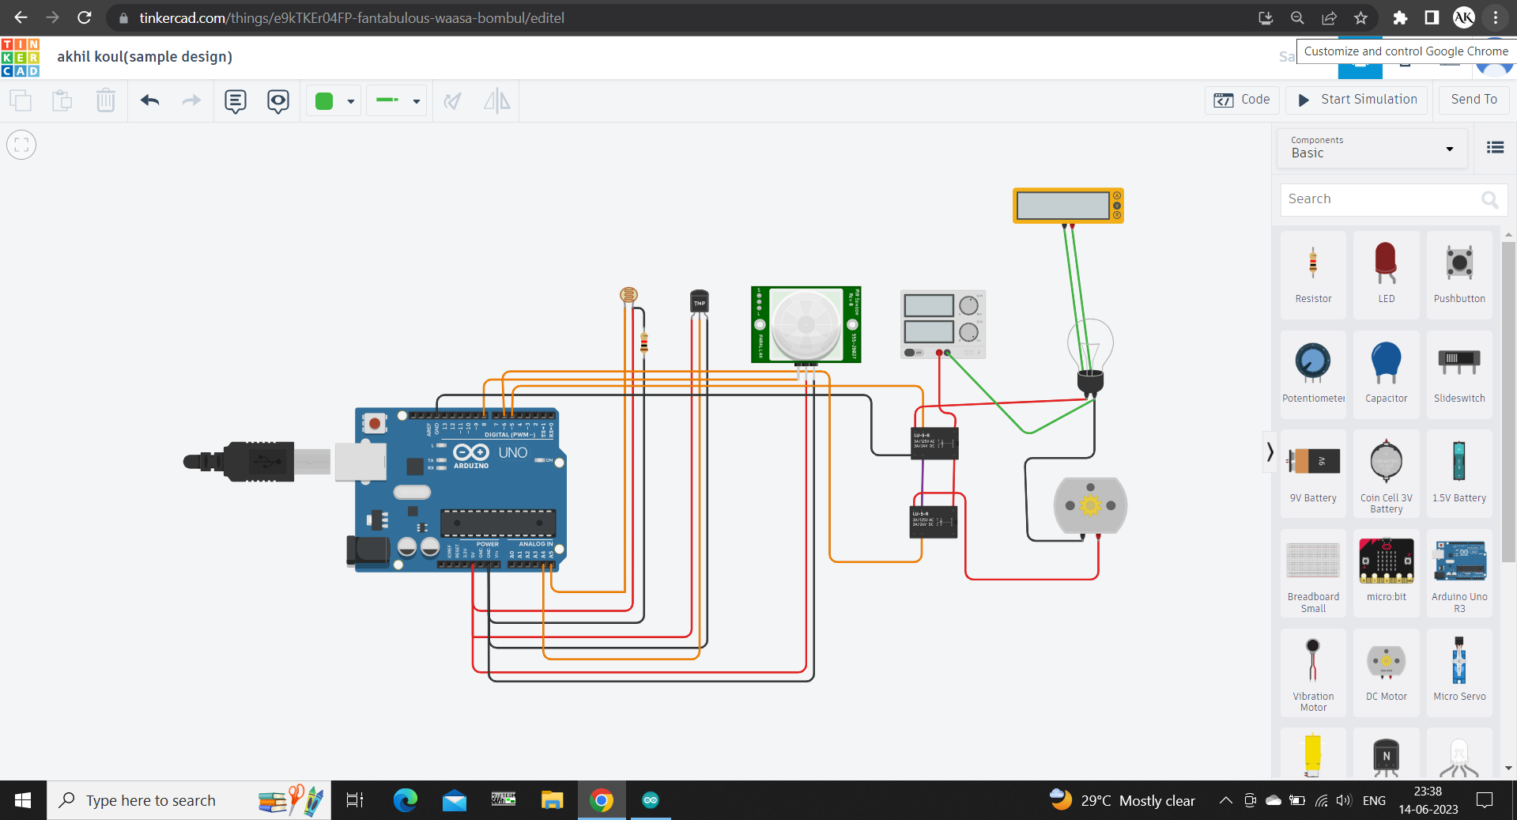

Figure

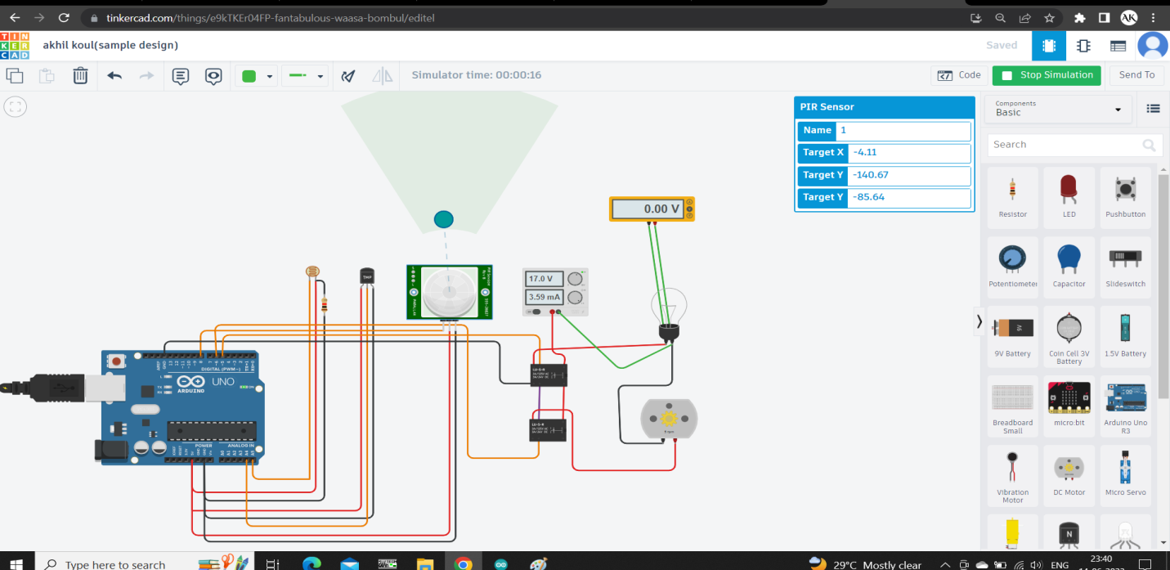

Figure

* Fig.10 and Fig.11 shows circuit flow using arduino microcontroller. Also I have demonstrated the use of PIR and LDR sensor

## High Level Diagrams

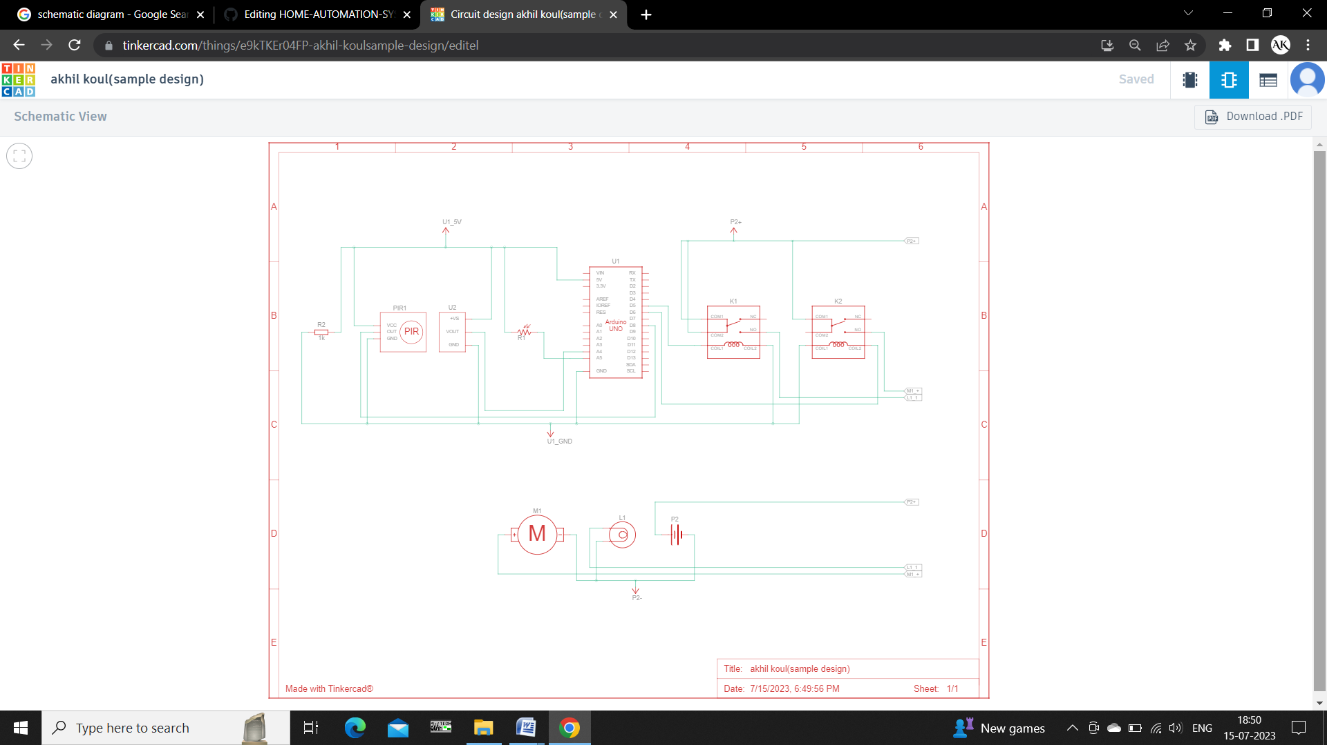

Figure

## BLYNK Interfaces

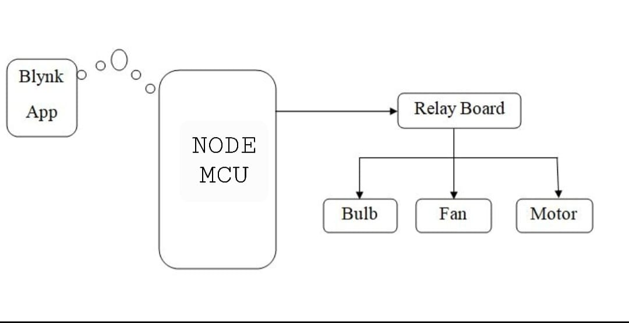

Figure

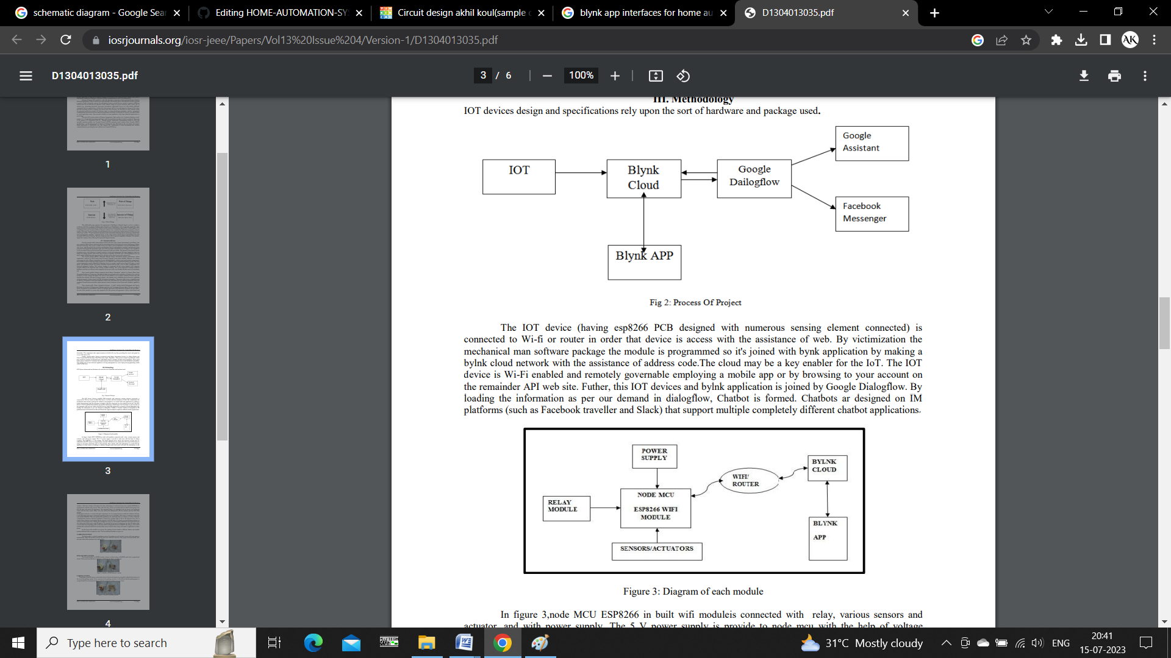

Figure

* In the following block diagrams NODE MCU is connected with relay, sensors and with power supply. The 5V power supply is provided to NODE MCU with the help of laptop or any adapter.
* Block diagram above also shows the electrical systems that are controlled with IOT system by using wireless network. The devices are connected to the router in the house.
* Human will send information to switch ON the appliances in their home or building or industry through router and router will send the information to the controller.
* After that, controller will analyze the data with the help of WiFi Serial Transceiver module to communicate with the relay circuits.
* Then, after the relay circuit has received the data on which switch is going to be ON, the data will be send to the appliances

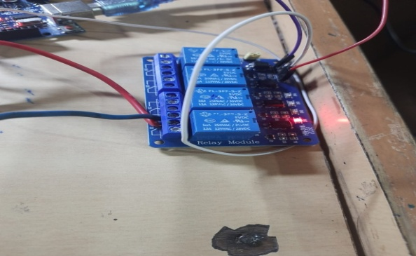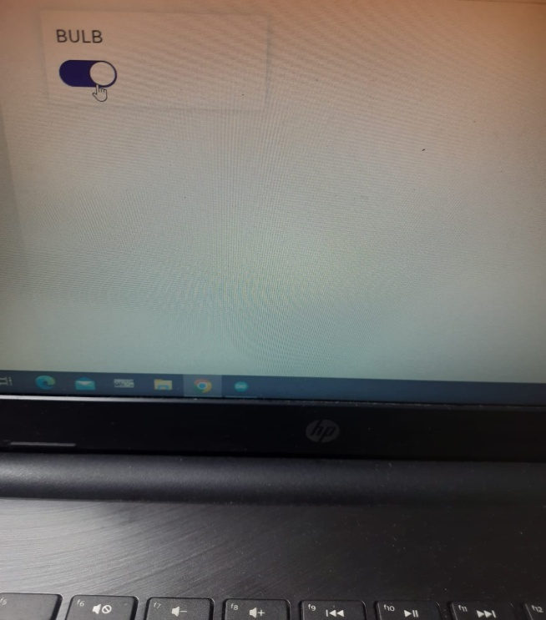

Figure

* Blynk template and interface for the home automation device:

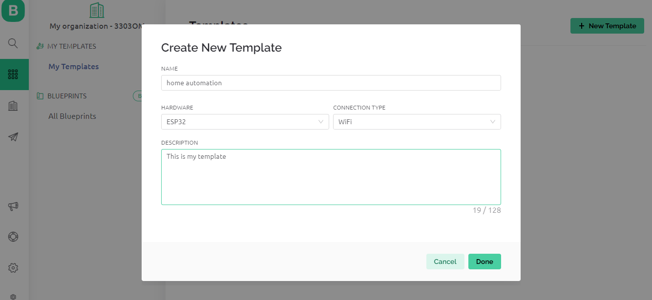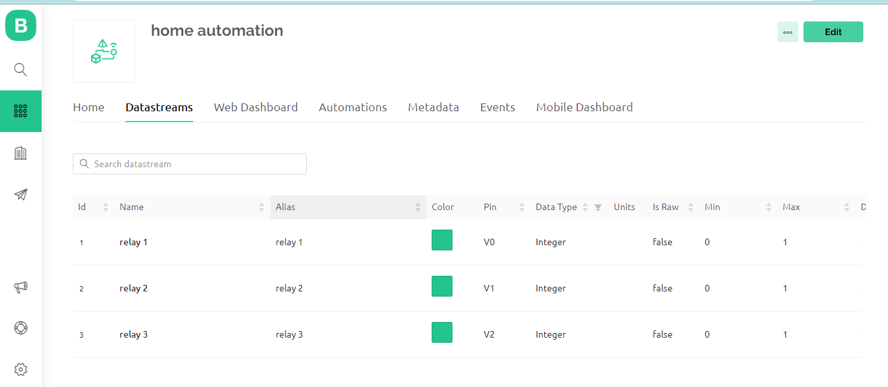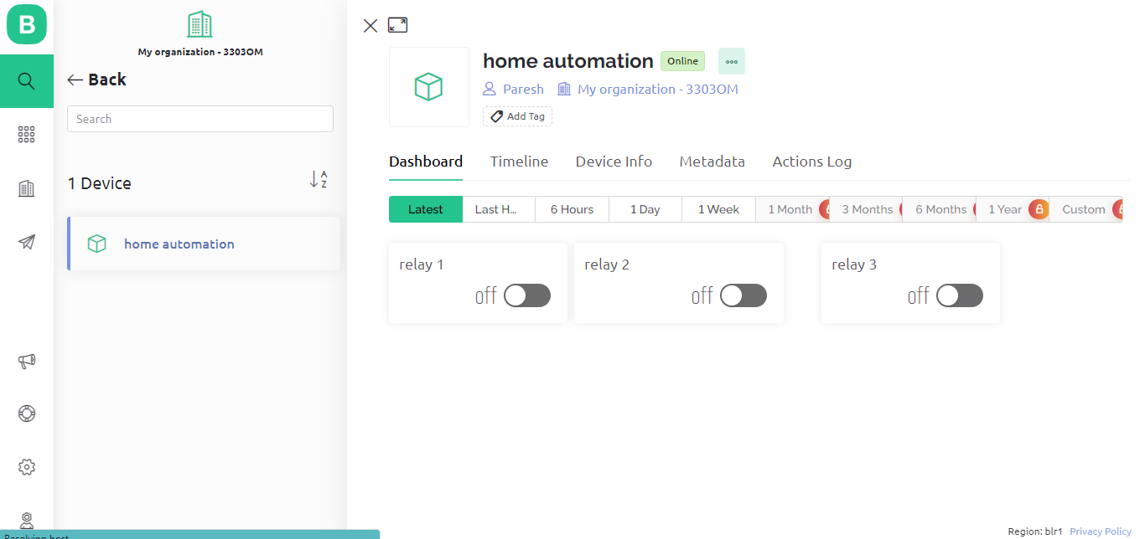

Figure

# Performance Test

HOME AUTOMATION has evolved a lot and it is a growing industry as everybody wants to make life easier and effective with the controls of everything within the reach of their pockets. Including numerous applications and widespread usage, several factors have led to its transformation into a significant market. Some of the factors are as follows:

* **ENERGY CONSUMPTION:**

The energy-saving potential of home automation systems, which efficiently control lighting, heating, and cooling based on occupancy, weather conditions, and user preferences, has captured the interest of individuals, businesses, and governments. This attraction stems from their desire to minimize their carbon footprint and decrease energy costs.

* **BETTER INTEGRATION:**

The increased prevalence of high-speed internet and the introduction of wireless communication standards such as Wi-Fi and Bluetooth have greatly enhanced device connectivity within households. This has facilitated the seamless integration and communication between diverse home automation systems, leading to a more holistic and streamlined user experience. Consequently, individuals can enjoy a unified and cohesive interaction with their interconnected smart devices and automation systems.

* **INDUSTRIAL PRESPECTIVE:**

The promising prospects of home automation have drawn the attention of numerous companies and startups, prompting them to make substantial investments in research, development, and marketing. This heightened competition has sparked innovation, leading to the introduction of novel products, enhanced features, and competitive pricing.

## Test Plan

* **Setup:**

1. Gathering necessary components
2. Downloading necessary software
3. Registrations in Third Party Cloud to be used
4. Establishing connectivity like WiFi and Bluetooth

* **Components Required:**

1. Esp32
2. Arduino
3. Relay Module
4. Breadboard
5. PIR Motion Detection Sensor
6. LDR Sensor
7. Resistors
8. Jumper Wires
9. AC Supply
10. Load
11. Electrical Wires

## Test Cases

* Confirm the successful installation of the Arduino IDE.
* Validate the connection between the hardware components.
* Ensure accurate identification and registration of all devices within the system.
* Verify the initial configuration and settings of the home automation system.
* Test basic functionalities, such as controlling lights or running an AC

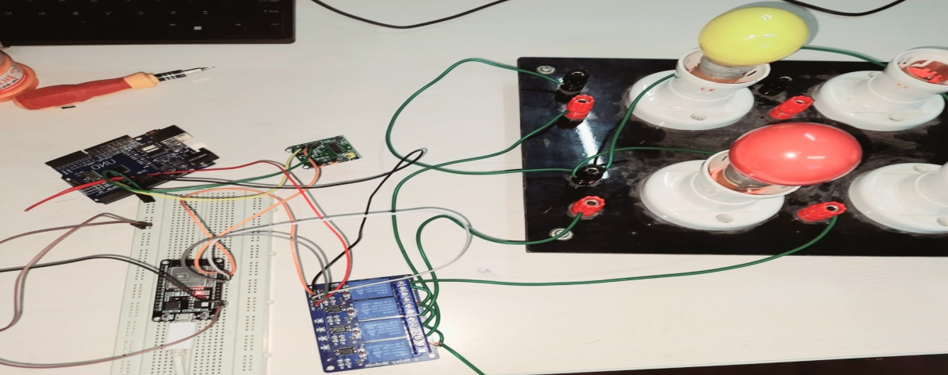

Figure

## Test Procedure

**STEP 1:** Decide what parts of the system to test and how to test them.

**STEP 2:** Connect all the devices and install the required software.

**STEP 3:** Test if the devices can be controlled properly, like turning them on or off.

**STEP 4:** Try out the automatic routines and rules you set up to see if they work correctly.

**STEP 5:** See how fast the system responds to commands and how well it handles many devices at once.

**STEP 6:** Make sure the system is secure and protects against unauthorized access.

**STEP 7:** Check if the system works well with different devices and platforms.

**STEP 8:** Test if the system is easy to use and understand for regular users.

**STEP 9:** After any changes, test to ensure nothing else got affected.

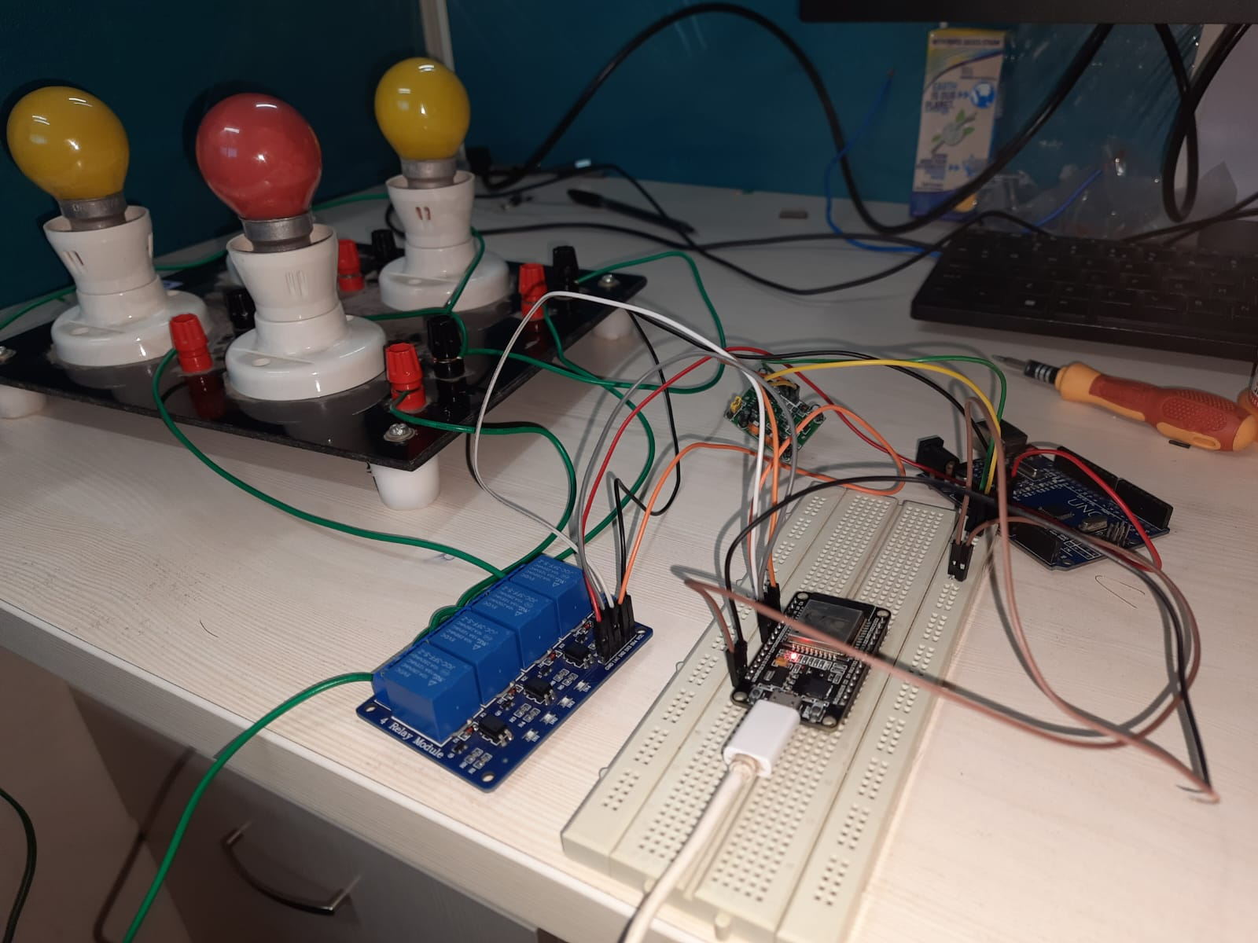

Figure

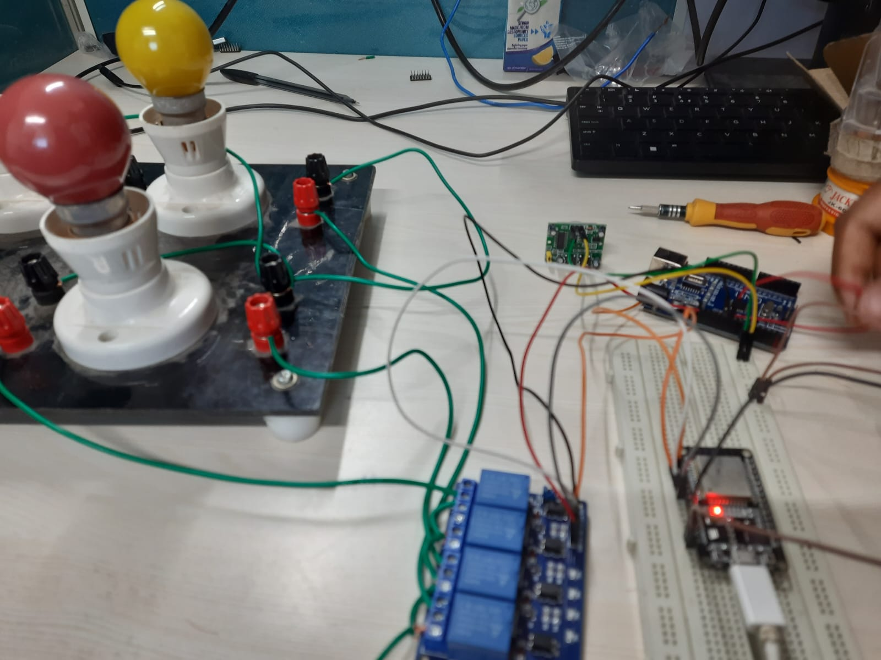

Figure

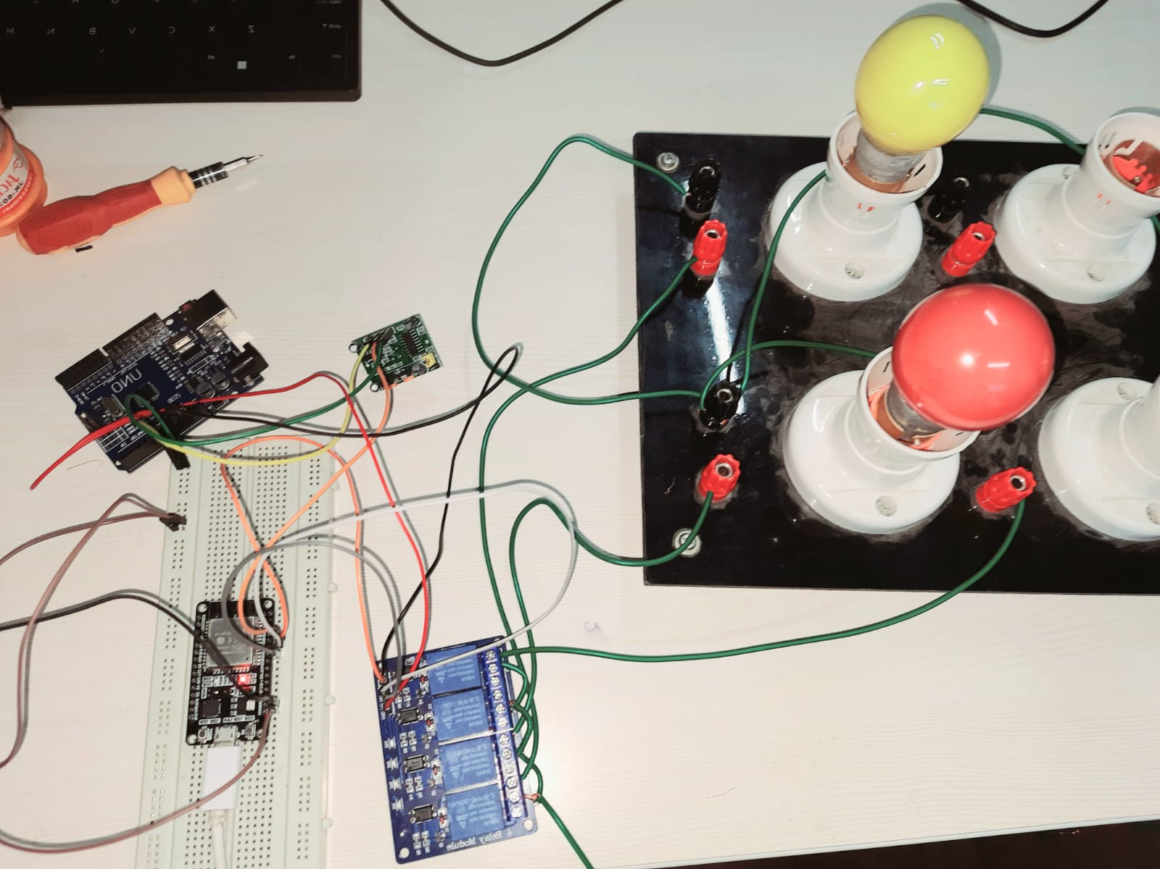

Figure

## Performance Outcome

* **Energy Efficiency:** Since we have automated the home appliances there was minimum 40% reduction in unnecessary usage of electricity
* **Load Handling**: The system was kept running for half an hour and the load applied were three small bulbs with low power consumption. After that three highly rated bulbs in power consumption were tested. In both cases the system responded well and the heat emitted was minimal.
* **Latency:** The delay between turning switches ON and OFF was barely any. The devices responded immediately to each command given
* **Reliability:** In terms of reliability, it lags this function as sometimes it produces unnecessary errors in functionality. This can be solved by properly ensuring system connections and connectivity.
* **Scalability:** In terms of scalability, it can handle number of devices at the same time, thus making it very much scalable for future use.
* **Network Performance:** The network connectivity between devices is very much compatible and with each devices responding quickly to the commands given.
* **User Interface:** Since we have used BLYNK interface as a third party service, we cannot control or edit the user interface experience. The default interface provided by BLYNK is also very easy and appealing.

# 7 MY LEARNINGS

In my complete journey of designing and implementing Home Automation as my internship project I have learnt some of the important fundamental principles of automation. I have learned how it works and how to set up the complete procedure of Home Automation. I now understand how different devices can work together, like lights, AC, and fans. Throughout my internship project, I have gained a profound understanding of the fundamental principles and inner workings of home automation.This experience has enabled me to automate tasks and create seamless interactions between these devices, like automatically turning on lights upon entering a room.

Navigating through challenges and problem-solving during this journey has honed my skills, making me adept at troubleshooting common issues in the home automation setup. Overall, I now possess valuable knowledge and expertise, allowing me to optimize my living space, making it smarter, more efficient, and convenient.

Hands-on practical experience has played a pivotal role in my learning process. From hardware installation to configuring smart devices, sensors, and controllers, I have acquired in-depth knowledge of the entire system's physical components and their interplay in forming a cohesive network.

One of the most captivating aspects of my learning journey has been exploring the possibilities of device compatibility and integration. I have delved into how different smart devices seamlessly work together within the home automation ecosystem, fostering a unified and interconnected environment. Overcoming challenges related to integrating devices from various manufacturers has been an invaluable lesson, ensuring smooth communication and cooperation between them.

Overall, my journey into home automation has enriched me with comprehensive knowledge and practical skills. Leveraging the power of technology, I have transformed my living space into a safer, more energy-efficient, and personalized environment. The continuous exploration and innovation within the home automation realm excite me, as I anticipate unlocking even more exciting advancements and applications in this transformative technology.

# 8 Future Scope

The current project's decision-making relies solely on one PIR motion sensor, leaving it vulnerable to potential errors. To enhance its capabilities and accuracy, incorporating multiple sensors such as LDR sensors and temperature sensors is proposed. By integrating these additional sensors, the system can make more informed decisions, such as turning appliances ON or OFF based on environmental conditions like light intensity or temperature.

Moreover, introducing voice recognition features will enable users to control and manage appliances through voice commands, adding convenience and potentially integrating security features. This expansion opens up possibilities for creating a comprehensive and user-friendly home automation experience.

Additionally, the project can benefit from data storage on the cloud, enabling the collection of valuable data over time. By leveraging machine learning algorithms to analyze this data and identify patterns, the system can make even smarter decisions in the future.

The scope of home automation is continuously evolving, and by incorporating these enhancements and increasing the range of features, the project aims to provide the best possible user experience while delivering optimal results.